Lab 6 (50 points)

Q1- (25 points) Consider the following program

Data segment:

|  |  |  |  |  |  |  |  |  |  |  |  |  |
| --- | --- | --- | --- | --- | --- | --- | --- | --- | --- | --- | --- | --- |
| **var1** | **dd** | **179**   |  |  |  |  |  |  |  |  |  |  | | --- | --- | --- | --- | --- | --- | --- | --- | --- | --- | | B3 | 00 | 00 | 00 |  |  |  |  |  |  |   var1 |
| **var2** | **db** | **0A3h, 017h, 012h**   |  |  |  |  |  |  |  |  |  |  | | --- | --- | --- | --- | --- | --- | --- | --- | --- | --- | | B3 | 00 | 00 | 00 | A3 | 17 | 12 |  |  |  |   var1 var2 |
| **var3** | **db** | **“bca”**   |  |  |  |  |  |  |  |  |  |  | | --- | --- | --- | --- | --- | --- | --- | --- | --- | --- | | B3 | 00 | 00 | 00 | A3 | 17 | 12 | 62 | 63 | 61 | |
|  |  | var1 var2 var3 |

Code:

**mov eax, var1** 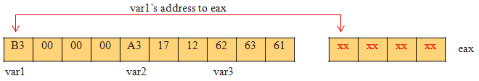

**add eax, 3**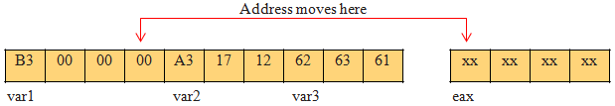

**mov ebx, [eax]** 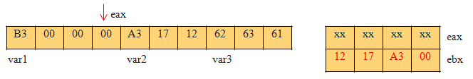

**add ebx, 5**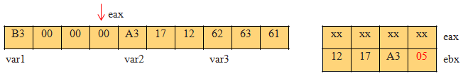

**mov [var1], ebx**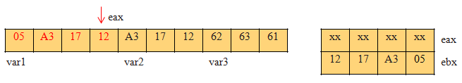

Show the contents of memory and registers before and after each instruction. Then show the final layout of the below memory starting at address “var1” on a Little-Endian Machine.

var1

|  |  |  |  |  |  |  |  |  |  |
| --- | --- | --- | --- | --- | --- | --- | --- | --- | --- |
| 05 | A3 | 17 | 12 | A3 | 17 | 12 | 62 | 63 | 61 |

Q2- (25 points) Consider the following program

Data segment:

|  |  |  |  |  |  |  |  |  |  |  |  |  |  |
| --- | --- | --- | --- | --- | --- | --- | --- | --- | --- | --- | --- | --- | --- |
| **var1** | | | | **dd** | | | **“b, “ca”, 0** | | | | | | |
| **var2** | | | | **db** | | | **3, 0, 0, 0** | | | | | | |
| **var3 times 2** | | | | **dw** | | | **012h** | | | | | | |
| 62 | 63 | 61 | 00 | | 03 | 00 | | 00 | 00 | 12 | 00 | 12 | 00 | |

var1 var2 var3

Code:

**mov eax, var3**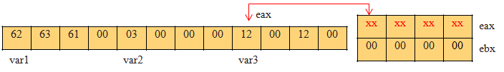

**mov ebx, var1**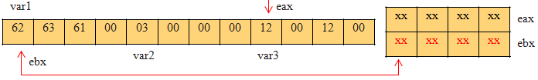

**sub eax, 4** 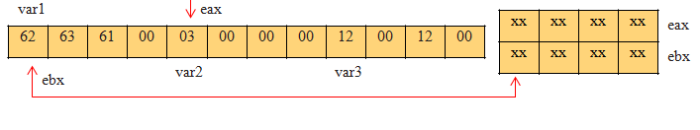

**add ebx, [eax]** 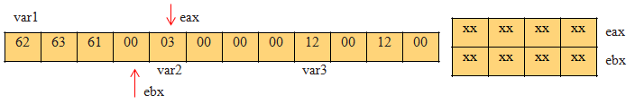

**mov dword [ebx], 42 (42 is 2Ah)**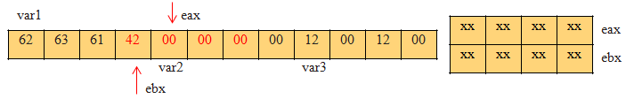

Show the contents of memory and registers before and after each instruction. Then show the final layout of the below memory starting at address “var1” on a Little-Endian Machine.

var1

|  |  |  |  |  |  |  |  |  |  |  |  |
| --- | --- | --- | --- | --- | --- | --- | --- | --- | --- | --- | --- |
| 62 | 63 | 61 | 42 | 00 | 00 | 00 | 00 | 12 | 00 | 12 | 00 |